Url Slug Suggestion - https://rootcabs.com/services/outstation
Primary Keyword

outstation tax
outstation cab booking
Secondary Keyword

outstation cab booking
car booking for outstation
outstation car rental
outstation cabs one way
hire driver for outstation
best one way taxi
car hire for outstation
outstation cabs near me
round trip cab booking
outstation cab booking near me
hire driver for outstation near me
book taxi for outstation
driver on hire for outstation charges
cab outstation booking
online outstation cab booking
best app for outstation cab booking
out of station car booking
one way trip cab
best cab booking app for outstation

Page Layout


H1 - Outstation Taxi Service
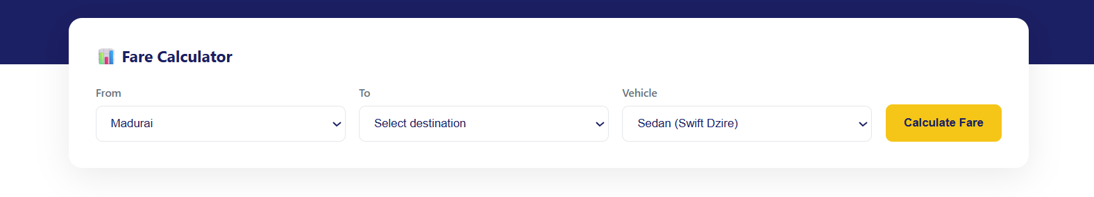

H2 - Benefits of the Outstation Taxi
H2 - One-Way vs Round-Trip Pricing, Explained
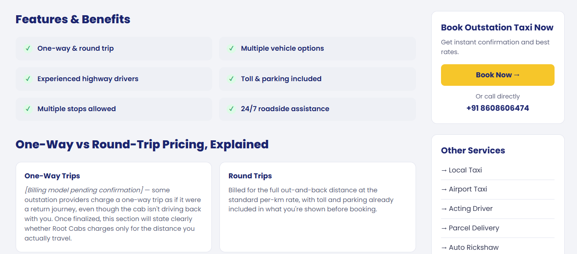

H2 - Why Root Cabs for Outstation Travel
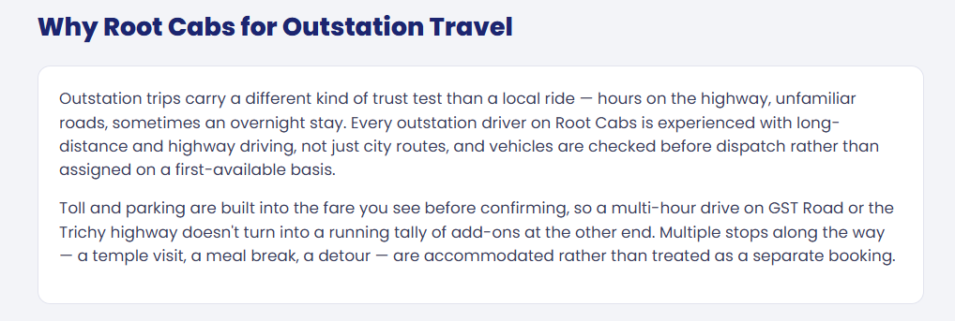

Please add relevant content to this section, including internal links to the Chennai and Vellore pages and other relevant pages where appropriate.

H2 - Popular Outstation Routes

H3 - Chennai - Vellore
H3 - Chennai - Pondicherry
H3 - Chennai - Tirupati
H3 - Madurai - Rameswaram
H3 - Coimbatore - Ooty
H3 - Trichy - Chennai

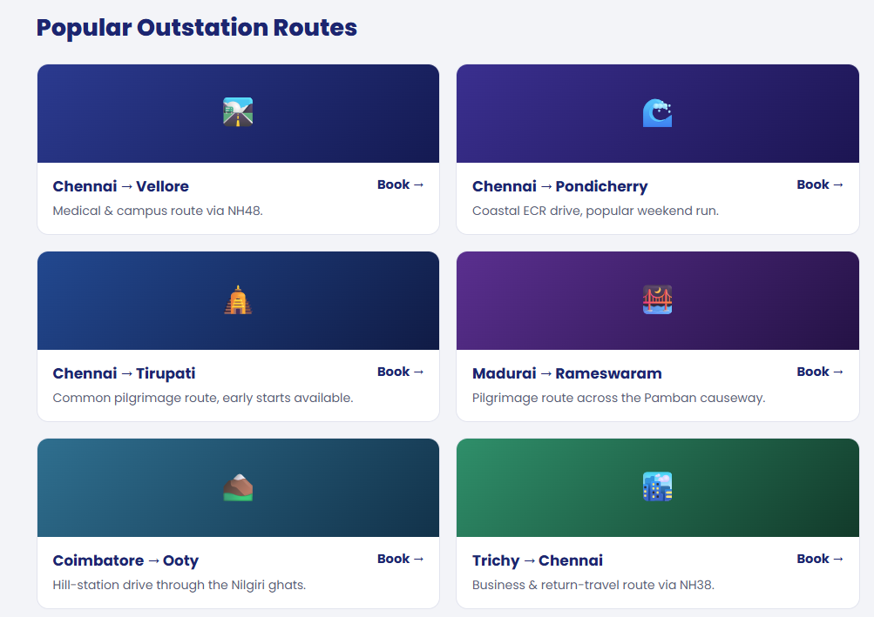

H2 - Outstation Taxi Available In
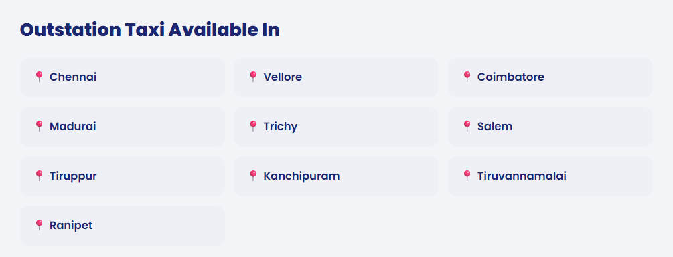

H2 -

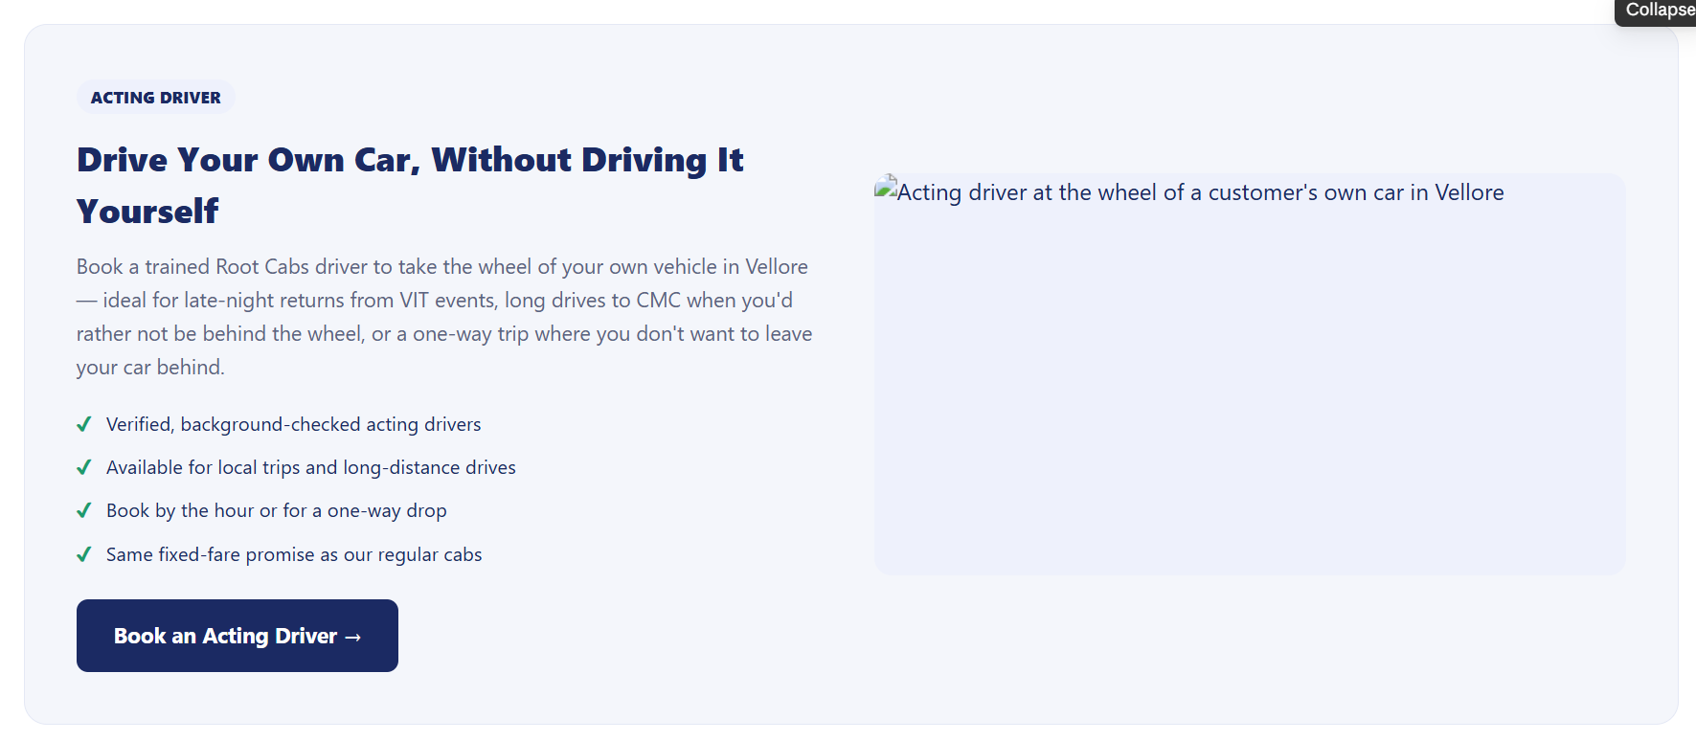

Acting driver section added - Purpose interlinking to the acting driver page.
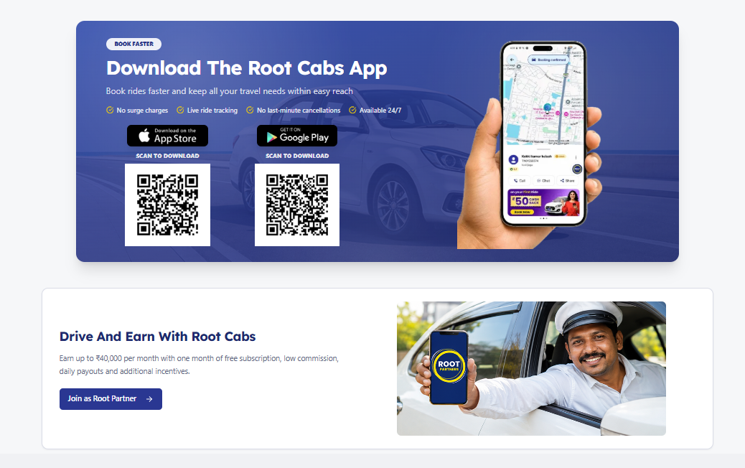

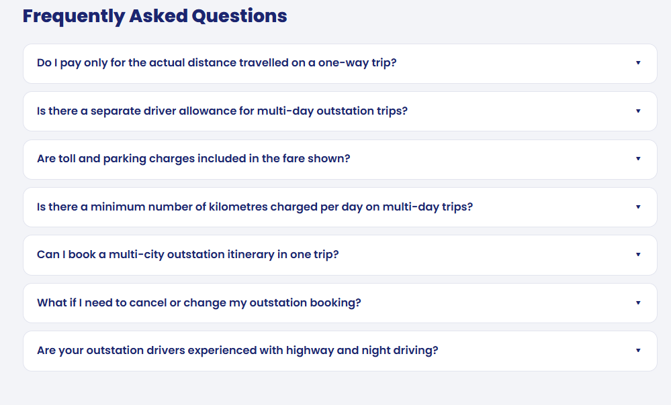
Are toll and parking charges included in the fare shown?
Does Root Cabs have outstation taxi service from Chennai to other cities in Tamil Nadu?
Can I book a multi-city outstation itinerary in one trip?
Are your outstation drivers experienced with highway and night driving?
Do I pay only for the actual distance travelled on a one-way trip?

